**A Web Based Healthcare**

**System Using Machine Learning**

M.M. Sangeetha N. Sri Krishna Kowshik N. Yeshaswini

Dept of Computer Science and Dept of Computer Science and Dept of Computer Science and

Engineering Engineering Engineering

Kalasalingam academy of research and Kalasalingam academy of research and Kalasalingam academy of research and

education education education

Krishnankoil,, Virudhunagar, Krishanankoil, Virudhunagar, Krishnankoil, Virudhunagar, Tamil Nadu, India Tamil Nadu, India Tamil Nadu, India

Sangeetha.m@klu.ac.in 9921004491@klu.ac.in 99210041479@klu.ac.in

**Abstract:**

This study provides the development and implementation of a comprehensive web-based healthcare system that leverages machine learning to improve the diagnosis, treatment, and management of a wide range of health conditions. Machine learning is used in this web-based healthcare system to enhance the diagnosis, management, and treatment of a number of medical disorders. By combining previous medical records, real-time patient data, and prediction algorithms, it provides tailored insights and treatment suggestions, promoting effective and easily accessible healthcare. Machine learning models, such as supervised learning for diagnosis and natural language processing (NLP) for processing unstructured data like doctor's notes, are powered by data from sources like electronic health records (EHRs), wearable technology, and Internet of Things-enabled health monitors. A real-time symptom checker, illness risk prediction, and tailored therapy suggestions based on lifestyle, health history, and present symptoms are some of its key features. It serves as a clinical decision support tool for medical professionals, offering data-driven insights and a thorough perspective of patient data to help with well-informed decisionmaking. This approach improves patient care, early detection, and patient engagement, and healthcare quality.

**Keywords:**

Diagnosis support, Treatment recommendations, Real-time patient data, Electronic health records (EHR), Symptom checker,

Personalized healthcare, Clinical decision support tool

**I.INTRODUCTION**

The rapid advancement of digital technologies has revolutionized healthcare delivery, with web-based platforms and machine learning systems offering new ways to enhance patient care. This introduces an innovative web-based healthcare system that harnesses the power of machine learning to assist in disease diagnosis, brain tumour prediction, and personalized health monitoring. The system is designed to offer comprehensive health services, from symptom-based disease prediction and brain

tumour prediction using the MRI scans, and even allows patients to book medical appointments through the platform. By integrating multiple features into a single accessible platform, this system aims to improve healthcare accessibility, diagnostic accuracy, and patient engagement.

One of the primary functions of the system is its ability to predict diseases based on user-reported symptoms. Patients can input their symptoms into the system, which uses machine learning algorithms to analyze and match them against a database of known conditions. The system then provides a list of possible diseases, diet, workouts, and precautions in managing their health and potentially reduces the burden on healthcare providers by streamlining the initial diagnostic process.

Additionally, the system incorporates a brain tumor prediction module, which leverages machine learning models trained on MRI scans data. By analyzing the images, the images, the platform can detect early signs of brain tumours, offering a fast, accurate and non-invasive diagnostic tool. This capability can be particularly beneficial in improving early detection rates and enabling timely interventions for brain cancer patients, which is critical for better outcomes and survival rates.

Furthermore, the system includes functionality for tracking and managing heart disease. User can log their daily blood pressure readings, and the system monitors trends over time, alerting patients to any significant changes or risks. This continuous tracking provides valuable insights, allowing individuals with hypertension or other cardiovascular conditions to manage their health more effectively.

To enhance patient convenience, the platform also allows users to book medical appointments directly through the website. This integration makes it easy for patients to schedule consultations with healthcare providers, ensuring timely access to medical care.

Whether they need to follow up on their symptom analysis, undergo further diagnostic testing, or consult with a specialist, the system streamlines the appointment process, contributing to a more efficient healthcare experience.

**II. LITERATURE SURVEY**

This provides discuss the existing research and advancements in machine learning-based healthcare systems, focusing on symptom-based disease prediction, brain tumour prediction from MRI scans, blood pressure monitoring, and online appointment booking. The proposed system incorporates these functionalities into a web-based platform that offers accessible, accurate healthcare services to users. Below, we review the relevant literature in each of these areas, drawing from peer-reviewed research papers and existing systems.

[]Semigran et al. (2015) evaluated the accuracy of several online symptom checkers, finding that these systems correctly diagnosed the top condition in 34% of cases, with the correct diagnosis being included in the top 3 results 51% of the time.

[]Chaudry et al. (2019) developed a Bayesian network-based system that uses patient-reported symptoms and medical history to predict possible diagnosis. Their model, trained on a large dataset from the National Health Service (NHS), achieved an accuracy of 71% when predicting the correct diagnosis from a list of possible conditions.

[]Rathore et al. (2021) developed a Convolutional neural network (CNN) model for brain tumor classification using MRI images. The study utilized the BraTs 2020 dataset and achieved 91.67% accuracy in distinugushing between tumor types (glioma, meningioma, and pituitary tumors).

[]Zhu et al. (2020) introduced a hybrid machine learning approach combining logistics regression and support vector machines (SVMs) to tract blood pressure readings and predict future health risks. Their system proved effective in forecasting long-term blood pressure trends and tailoring treatment plans based on predicted outcomes.

[]Dantas et al. (2018) conducted a systematic review of appointment scheduling systems in healthcare, highliting the importance of using predictive models to optimize patient flow and reduce administrative overhead. The review emphasized the use of real-time data and machine learning algorithms for improving patient and provider satisfaction.

**III.SECTION BACKGROUND**

**a. SYMPTOM CHECKER**

PROPOSED WORK:

The proposed system predicts diseases based on user-reported symptoms using the support vector Machine (SVM) model. This model is effective for multi-class classification, making it suitable for identifying various diseases from a set of input symptoms. The dataset includes symptoms, diseases, precautions, medications, diets, and workouts. The system is intended to provide both healthcare professionals and patients with a reliable tool to diagnose diseases and suggest treatments or precautions based on symptoms.

METHODOLOGY:

Data Preprocessing:

The symptom-disease dataset was cleaned by handling missing values and normalizing input features to ensure consistency. The symptoms form the input features, and the disease category serves as the target variable. The data was divided into training and testing sets to evaluate the model’s performance.

Model Selection:

The SVM algorithm was chosen for its strong performance in classification problems, especially for medical diagnosis tasks. The one-vs-rest approach was employed to handle multi-class classification. Model evaluation metrics include accuracy, precision, recall, and F1-score.

Training and Evaluation:

The SVM model was trained using the Scikit-learn library in python. The model was optimized to predict diseases based on symptoms. Cross-validation techniques were applied to ensure robust performance and minimize overfitting. A confusion matrix was used to further analyse misclassification.

Flask Web Application:

A Flask-based web application was developed where users input their symptoms through an HTML form. The backend process this input to predict possible diseases using the trained SVM model. The output includes the predicted disease along with suggested treatments, precautions, medications, diets, and workouts. Prediction:

The system takes symptoms as input via the web application and provides real-time predictions for diseases with treatment suggestions and other related outputs being displayed on the result page.

**b. BRAIN TUMOUR DETECTION**

PROPOSED WORK:

The proposed system integrates a CNN-based approach for brain tumour detection. The architecture chosen for this task is VGG16, a pretrained convolution neural network model that has remarkable accuracy in image classification tasks. The model is fine-tuned using a dataset of brain MRI images to classify the presence of a brain tumour. A Flask web application serves as the font-end interface, allowing users to upload images and view predictions.

The primary goal is to develop an accurate system for healthcare providers and patients, which can assist in early-stage detection of brain-related conditions. The system predicts whether the uploading brain MRI scan is indicative of a tumour or not.

METHODOLOGY:

Data Collection and Preprocessing:

The dataset comprises brain MRI images, with image resized to 224x224 pixels to fit the input size required by the VGG-16 model. The data is augmented to prevent overfitting and to improve model robustness.

Model Architecture:

The VGG_!6 model is used as the core of the proposed solution. The model is pre-trained on the ImageNet dataset and fine-tuned on brain MRI image for binary classification. The final layers of the model are customized for the current classification task.

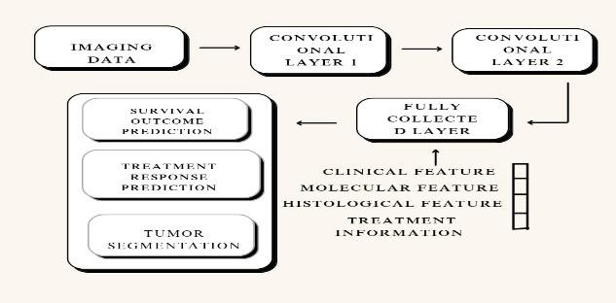

Training Process:

The model is trained using a cross-entropy loss function, optimized with Adam optimizer, and evaluated using metrices such as accuracy, precision, and recall. Various hyperparameters such as learning rate, batch, size, and epochs are tuned to achieve optimal performance.

Flask Application:

A flask web app is designed to provide a simple and interactive user interface. Users can upload brain MRI images through the trained model, and returns the result on the web page.

Prediction:

Upon image upload, the image is preprocessed a (resized, normalized) and passed through the VGG_16 model for prediction. The output is displayed on the web page, alongside the uploaded image.

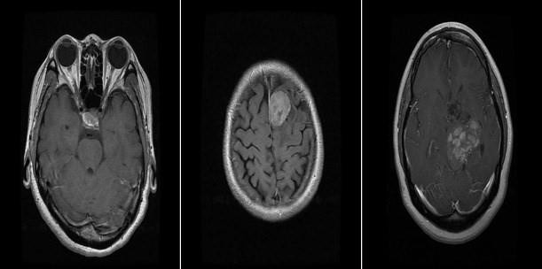 ALGORITHMS USED:

Convolutional Neural Network:

CNNs are widely used for image classification tasks. VGG-16, a specific CNN architecture, is employed here. VGG-16 is known for its deep layers and small filter sizes, which are highly effective for feature extraction in images.

VGG-16:

This is a deep VNN-model with 16 laVGG-16: This is a deep VNN-model with 16 layers, including convolutional layers followed by max-pooling layers, and fully connected layers at the end. It is known for its balance between depth and simplicity, making it a strong choice for classification tasks.

**c. HEART DISEASE**

PROPOSED WORK:

The proposed system predicts the likelihood of developing heart disease based on patient data. The logistic regression algorithm is chosen due to its robustness and interpretability in binary classification tasks. The dataset used for training the model is the Framingham Heart Study dataset, which contains medical records Data Preprocessing:

The Framingham dataset was cleaned by removing rows with missing values to ensure the quality of the data. The target variable is the ‘TenYearCHD’ feature, which indicates the presence or absence of heart disease risk over a 10-year period. Features used for the prediction include ‘age’, ‘currentsmoker’, ‘BMI’, ‘sysBP’, ’glucose’, among others.

Model Selection:

Logistic regression was chosen for this due to its effectiveness in predicting binary outcomes. The model evaluated using accuracy as the key metric.

Training and Education:

The logistic regression model was trained using the scikit-learn library in python. The dataset was split into training and testing sets, and the model was trained to protect whether an individual is at risk of heart disease. Accuracy, precision, recall, and the confusion matrix were used to evaluate model performance.

Flask Web Application:

A Flask-based web application was developed to serve the model predictions. Users input their health parameters (age, cholesterol, blood pressure, etc) via HTML form, and the backend processes the input to make a prediction using the logistic regression model. The prediction result, whether the individual is at risk of heart disease or not, is then displayed on the web page.

Prediction:

The input features are collected via the Flask application, and the pre-trained logistic regression model is used to predict the likelihood of heart disease. The prediction is returned in real time, allowing users to get instant results based on their input datazx

ALGORITHMS USED

Logistic Regression:

Logistic regression isa statistical method that models the probability of a binary outcome. It is widely used in medical applications where the objective is to predict the occurrence of a disease based on a set of features.

**d. LIVER**

PROPOSED WORK:

The proposed system aims to predict liver disease using a machine learning model based on clinical parameters such as age, gender, liver enzyme levels, and more. Random Forest, an ensemble method known for its robustness and ability to handle complex datasets, is employed as the primary model. The study aims to enhance predicton accuracy through hyper parameter tuning and comparative analysis with other classifiers like Logistic Regression and support vector machines.

METHODOLOGY:

Data Preprocessing:

The indian liver patient dataset, consisting of health parameters like age, gender, bilirubin, SGPT, SGOT, and albumin levels, was used. The dataset was cleaned to handle missing values, with missing entries in the Albumin and Globulin Ratio filled using the mean value. Categorical variables such as gender were label

of individuals including features such as smoking static, encoded (Male = 1, Female = 0). cholesterol, systolic blood pressure, and glucose levels. The Model Selection:

system is designed to provide healthcare professionlas and The Random Forest Classifier was selected for its effectiveness in patients with a simple tool to assess heart disease risk. handling complex data. The dataset was split into training (80%)

METHODLOGY:

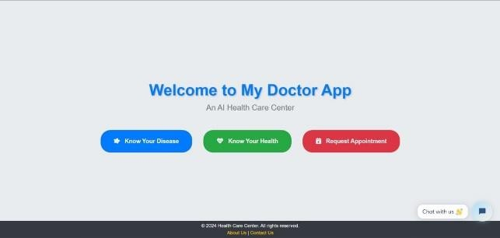and testing (20%) sets. The model was trained on the training data and evaluated using accuracy and confusion matrix metrics.

Flask Web Application:

A Flask-based web app was developed where users input health parameters through an HTML form. The input is processed by the pre-trained Random Forest model to predict the likelihood of liver disease, and the result is displayed in real-time on the web page.

Prediction:

Input features are collected via the web app, and the model outputs wheather a patient is likely to have liver disease. The prediction is displayed to the user along with a probability score based on the clinical parameters provided.

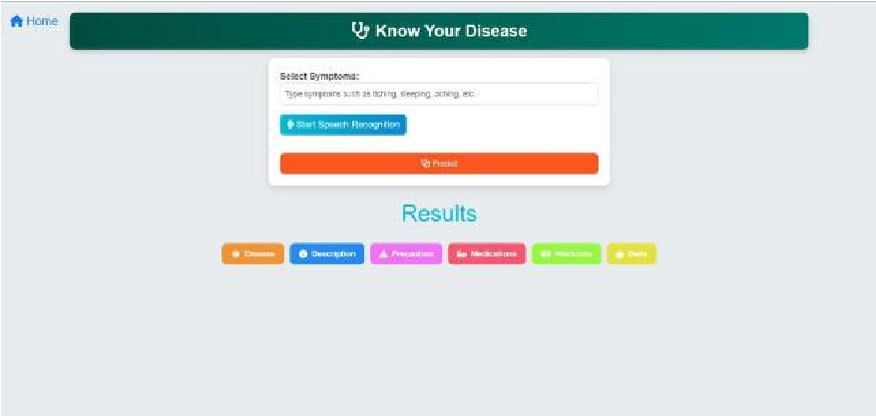ALGORITHMS USED:

Random Forest Classifier:

Random Forest is an ensemble learning technique that constructs multiple decision trees and outputs the mode of their predictions. it is highly suitable for liver disease prediction due to its capability to manage complex data and provide accurate predictions.

**CONCLUSION:**

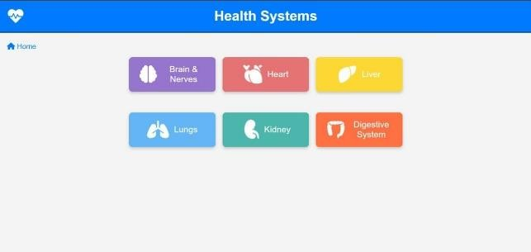In conclusion, the proposed Flask-based web application provides a comprehensive and user-friendly platform for predicting various health conditions, integrating multiple machine learning models tailored to specific disease prediction, VGG for brain tumour detection, Logical Regression for heart and lung disease prediction, and Random Forest for liver disease detection, this app offers a robust solution for early diagnosis and health risk assessment. The system empowers users and healthcare professionals alike by offering real-time, personalized health predictions based on input data, improving accessibility to health assessments without requiring extensive medical infrastructure.

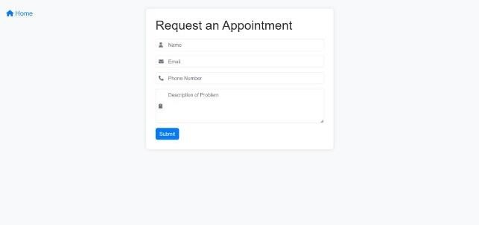The incorporation of the doctor appointment feature enhances the usability of the application, creating a seamless experience for patients to take action based on their health predictions. This project demonstrates the potential of machine learning in healthcare, offering cost-effective, scalable solutions for preventive care and early detection of diseases.

Future work could involve expanding the database to include more health conditions and improving model accuracy through additional data and fine-tuning of machine learning algorithms. Furthermore, incorporating secure data handling and privacy

measures would be crucial to ensure patient confidentially in real- world applications.

**OUTPUTS: REFERENCES:**

**The output of the healthcare prediction system is designed to be user-friendly and informative, presenting the predicted disease or condition based on the input data in a structed format. Alongside the prediction, the system provides relevant details, such as a description of the disease, suggested precautions, and possible medications. Additionally, the system offers personalized dietary recommendations and physical activity suggestions tailored to the predicted condition. For image-based predictions, such as brain tumour detection, visual representations of the processed medical images may also be displayed. The output ensures users receive clear, actionable insights into their health, helping them make informed decisions.**

1.Health workforce: the health workforce crisis. World Health Organization. 2009. Jun 24, [2023-05-04].

https://www.who.int/news-room/questions-andanswers/item/q-a-on-the-heal.

2.Lupton D, Jutel A. 'It's like having a physician in your pocket!' A critical analysis of self-diagnosis smartphone apps. Soc Sci Med. 2015 May; 133:128–35. doi: 10.1016/j.socscimed.2015.04.004. S0277-9536(15)00224-5

- DOI - PubMed

3.Alwashmi MF. The use of digital health in the detection and management of COVID-19. Int J Environ Res Public Health. 2020 Apr 23;17(8):906. doi: 10.3390/ijerph17082906.

https://www.mdpi.com/resolver?pii=ijerph17082906 ijerph17082906 - DOI - PMC - PubMed

4.North F, Ward WJ, Varkey P, Tulledge-Scheitel SM. Should you search the internet for information about your acute symptom?

Telemed J E Health. 2012 Apr;18(3):213–8. doi:

10.1089/tmj.2011.0127. - DOI - PubMed

5.Powley L, McIlroy G, Simons G, Raza K. Are online symptoms checkers useful for patients with inflammatory arthritis? BMC

Musculoskelet Disord. 2016 Aug 24;17(1):362. doi:

10.1186/s12891-016-1189-2.

https://bmcmusculoskeletdisord.biomedcentral.com/articles/10.1 186/s12891... 10.1186/s12891-016-1189-2 - DOI - DOI - PMC – PubMed.

6.Azziz R, Carmina E, Chen Z, Dunaif A, Laven JSE, Legro RS, Lizneva D, Natterson-Horowtiz B, Teede HJ, Yildiz BO. Polycystic ovary syndrome. Nat Rev Dis Primers. 2016 Aug

11;2:16057. doi: 10.1038/nrdp.2016.57. https://www.nature.com/articles/nrdp201657 nrdp201657 - DOI -

PubMed

7.Bozdag G, Mumusoglu S, Zengin D, Karabulut E, Yildiz BO. The prevalence and phenotypic features of polycystic ovary syndrome: a systematic review and meta-analysis. Hum Reprod. 2016;31(12):2841–2855. doi: 10.1093/humrep/dew218. https://academic.oup.com/humrep/article/31/12/2841/2730240?lo gin=false dew218 - DOI - PubMed

8.Carmina E, Azziz R. Diagnosis, phenotype, and prevalence of polycystic ovary syndrome. Fertil Steril. 2006;86(Suppl 1):S7– S8.doi:10.1016/j.fertnstert.2006.03.012.

https://linkinghub.elsevier.com/retrieve/pii/S0015-

0282(06)00722-9 S0015-0282(06)00722-9 - DOI - PubMed

9.Deswal R, Narwal V, Dang A, Pundir CS. The prevalence of polycystic ovary syndrome: a brief systematic review. J Hum ReprodSci.2020;13(4):261–271.doi: 10.4103/jhrs.JHRS_95_18. https://europepmc.org/abstract/MED/33627974 JHRS-13-261 - DOI - PMC - PubMed

10.Ellis K, Munro D, Clarke J. Endometriosis is undervalued: a call to action. Front Glob Womens Health. 2022; 3:902371. doi:10.3389/fgwh.2022.902371.

https://europepmc.org/abstract/MED/35620300-DOI - PMC - PubMed

11.van der Kleij RMJJ, Kasteleyn MJ, Meijer E, Bonten TN, Houwink EJF, Teichert M, van Luenen S, Vedanthan R, Evers A, Car J, Pinnock H, Chavannes NiH. SERIES: eHealth in primary care. Part 1: concepts, conditions and challenges. Eur J Gen Pract. 2019;25(4):179–189. doi: 10.1080/13814788.2019.1658190. https://europepmc.org/abstract/MED/31597502 - DOI - PMC -

PubMed

12.Timmers T, Janssen L, Kool RB, Kremer JA. Educating https://www.jmir.org/2020/4/e17342/ v22i4e17342 - DOI - PMC - PubMed

13.Hamine S, Gerth-Guyette E, Faulx D, Green BB, Ginsburg AS. Impact of mHealth chronic disease management on treatment adherence and patient outcomes: a systematic review. J Med Internet Res. 2015;17(2):e52. doi: 10.2196/jmir.3951. https://www.jmir.org/2015/2/e52/ v17i2e52 - DOI - PMC -

PubMed

14.Morrison D, Wyke S, Agur K, Cameron EJ, Docking RI, Mackenzie AM, McConnachie A, Raghuvir V, Thomson NC, Mair FS. Digital asthma self-management interventions: a systematic review. J Med Internet Res. 2014;16(2):e51. doi:

10.2196/jmir.2814. https://www.jmir.org/2014/2/e51/ v16i2e51 - DOI - PMC - PubMed

patients by providing timely information using smartphone and tablet apps: systematic review. J Med Internet Res.

2020;22(4):e17342. doi: 10.2196/17342.